

**CASE STUDY**

**1.What is the purpose of route 53 and significance of DNS in the context of Route 53?**

**A.** 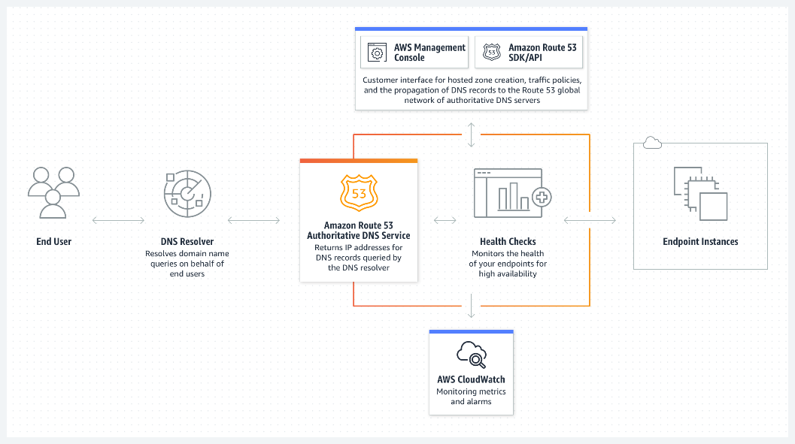

Amazon Route 53 ensures reliable and efficient routing of end users to your website by leveraging globally-dispersed Domain Name System (DNS) servers. With automatic scaling, the service dynamically adjusts to varying workloads, optimizing performance and maintaining a seamless user experience.

Amazon Route 53 is a highly available and scalable Domain Name System (DNS) web service. Route 53 connects user requests to internet applications running on AWS or on-premises.

Amazon Route 53 streamlines the setup of DNS routing by providing quick and easy domain name registration, complemented by straightforward visual traffic flow tools. This enables users to configure their DNS settings within minutes, simplifying the process of managing and directing web traffic efficiently.

Amazon Route 53 allows users to tailor DNS routing policies to specific needs, such as reducing latency, enhancing application availability, and ensuring compliance. This customization empowers users to optimize their DNS configurations for performance, resilience, and adherence to regulatory requirements.

**2. What is Amazon Cloud Front, and what problem does it solve?**

1. Amazon Cloud Front:

Amazon CloudFront is a web service that speeds up distribution of your static and dynamic web content, such as .html, .css, .js, and image files, to your users. CloudFront delivers your content through a worldwide network of data centres called edge locations. When a user requests content that you're serving with CloudFront, the request is routed to the edge location that provides the lowest latency (time delay), so that content is delivered with the best possible performance.

* If the content is already in the edge location with the lowest latency, CloudFront delivers it immediately.
* If the content is not in that edge location, CloudFront retrieves it from an origin that you've defined—such as an Amazon S3 bucket, a Media Package channel, or an HTTP server (for example, a web server) that you have identified as the source for the definitive version of your content.

CloudFront solves the problem of latency and slow loading times by caching content at edge locations around the world, closer to the end-users.

This reduces the distance data needs to travel, improving overall performance and user experience.

Additionally, it helps offload traffic from origin servers, reducing the load on infrastructure during high-demand periods.

 
    How CloudFront works 
   

**3. Explain the concept of "server less" computing in the context of AWS Lambda?**

**A.**

1. AWS Lambda is a serverless, event-driven compute service that lets you run code for virtually any type of application or backend service without provisioning or managing servers. You can trigger Lambda from over 200 AWS services and software as a service (SaaS) application, and only pay for what you use.
2. A serverless architecture is a way to build and run applications and services without having to manage infrastructure. Your application still runs on servers, but all the server management is done by AWS.
3. AWS Lambda is a serverless computing service provided by Amazon Web Services (AWS). Users of AWS Lambda create functions, self-contained applications written in one of the supported languages and runtimes, and upload them to AWS Lambda, which executes those functions in an efficient and flexible manner.
4. Lambda runs your code on high availability compute infrastructure and performs all the administration of your compute resources. This includes server and operating system maintenance, capacity provisioning and automatic scaling, code and security patch deployment, and code monitoring and logging. All you need to do is supply the code.
5. AWS Lambda is a serverless compute service that runs your code in response to events and automatically manages the underlying compute resources for you.

